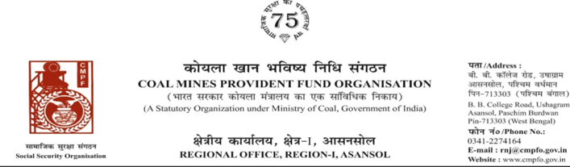
Ref. : CPF/118/Misc/RNJ/LC/OUT/R-I/ASN/ Date :21/07/2025
To,
The Regional Commissioner
Coal Mines Provident Fund Ranchi R-II
Darbhanga House CCL HQ.Ranchi University
Morabadi
Ranchi (Jharkhand) 834001
Sub:- Inter Regional Transfer of Ledger Card, DA, PS -3 & 4.
Ref:-ECL/SBP/GM/(MIN)/HR/CMPF/25/P-87 Date : 08/07/2025
Sir,
In view of the revised Procedures prescribed in Procedure Office Order No-35 Dated-12.02.1975 of CMPF Commissioner,Dhanbad, I am to state that the Ledger Cards of the following members along with Declaration in Form "A" Form-I (Pen),PS-3 & 4 may kindly be forwarded to this office as the member(s) is /are working in this region.
It may kindly be ensured that the posting in the Ledger Cards may be made updated for the periods the member was working in your Region.
SL. No | Name of the Member | CMPF A/C No | Name of the colliery where the member is currently working in | Name of the colliery where the member had earlier worked in | Name of the Company | Period of Posting
1 | Sri Avtar Singh | RMG/26/385 | SONEPUR BAZARI PROJECT  (RNJ/34) | B.T.T.I Bhurkundra  (Barkakana Area) | C.C.L | 22-10-1993 To 09-05-1996
 |  |  |  | Bhurkundra Colliery  (Barkakana Area) | C.C.L | 10-05-1996 To 31-03-2005
 |  |  |  | Gidi “C” Colliery  (Argada Area) | C.C.L | 05-04-2005 To 07-06-2012
 |  |  |  | Sonepur Bazari Project (S.B.Area) | C.C.L | 08-06-2012 To Till Date
In light of this, we kindly request you to do the needful action and kindly arrange the transfer of his ledger card from previous working zones and update the records accordingly.
Thank you for your attention to this matter.
Encl. :As above Posting Details ( Two copy )
Yours faithfully

Assistant Commissioner

